**JAVA INTERVIEW**

* Java is an object oriented programming language developed by James Gosling at Sun Microsystems (now merged with Oracle Corp)
* J2SE - Java 2 Standard Edition

- used to develop desktop/standalone applications

-standalone application- it is in only one computer

* - J2EE - Java 2 Enterprise Edition

- used to develop web applications

-web application:

* - J2ME - Java 2 Micro/Mobile Edition

- used to develop mobile applications

* Java Features:

-Simple

-Object Oriented

-Robust

-Platform Independent

-Interpreted

-Portable

-Secure

-Multithread

-Dynamic

-Distributed

* How to run a Java Program In Command Prompt
* javac filename.java(it may generate .class file called as object file)
* java filename.java(it will run the object file)
* static members are accessible directly with the class name without creating objects

>java Welcome.main()

* Scanner class is used to read values into variables from keyboard during program execution (runtime)

Scanner in = new Scanner(System.in);

Methods of Scanner class

------------------------

- nextInt() - used to read an int value

- nextFloat() - used to read a float value

- nextDouble() - used to read a double value

- next() - used to read a String value without spaces

- nextLine() - used to read a String value with spaces

* Variable

--------

It is an identifier which allocates some space in memory and the value in memory changes during program execution

* Rules for Identifiers (variable,method,class)

---------------------------------------------

- can contain a-z,A-Z,0-9,_,$

- cannot start with a digit (0-9)

- cannot be a keyword (reserved words)

* Primitive Data Types

datatype size default value

-----------------------------------

boolean 1 bit false

byte 1 byte 0

short 2 bytes 0

char 2 bytes ''

int 4 bytes 0

float 4 bytes 0.0

long 8 bytes 0

double 8 bytes 0.0

* Reference data types

---------------------

Other than primitive types are reference data types

Eg:

Arrays, Strings, Any object

* Default values are applicable only for the data members of the class not for local variables

- Local variable need to be initialized

* Casting

-------

The process of converting one primitive type to another primitive

type or one reference type to another reference type is called as casting

* Operators in java

-Arithmetic Operators -> +,-,*,/,% (modulus - remainder)

- Relational operators -> >,<,>=, <=, ==, != (not equal)

- Logical operators -> &&(AND), || (OR), ! (NOT)

- Assignment operators -> =, +=, -=, *=, /=, %=

- Conditional operator -> ? (ternary operator)

- Increment and decrement operators -> ++, --

* Types

-----

- if statement

- switch statement

- while loop

- do..while loop

- for loop

- break and continue

- labelled break and continue

-The **for-each loop** is used when we want to iterate through each and every element of a collection of elements.  
  
-The for loop is generally used when a piece of code has to be repeated n number of times i.e. when we know beforehand the number of iterations the loop should run.   
-The while loop is generally used when the loop's terminating condition happens at some time i.e. we do not know the number of iterations the loop should run, or when the termination condition arrives.  
  
-The do while loop is the same as while loop, except that it will always execute the body of the loop once before the condition is evaluated.

* difference between while loop and do..while loop

-------------------------------------------------

- In while loop condition is checked before the statements where as in do..while loop condition is checked after the statements

- In while the minimum no of executions of statements is zero where as in do..while loop the minimum of execution of statements is one

* If the value of condition is known in the loop statements then it is suggested to use do..while loop.
* break and continue

------------------

- break is used to come out of loop

- continue is used to continue the loop

* Arrays

------

An array is a collection of elements of similar data type and stored in continuous memory locations

-Arrays are used to store collection of homogenous elements

-we can assign and access those elements with index values(start with 0).

-Arrays are in fixed size.

* One dimensional arrays

----------------------

- In one dimensional array the elements are stored in the form of rows

Declaration

------------

syntax

------

datatype[] arrayname;

or

datatype arrayname[];

Memory Allocation

-----------------

int[] n = new int[5];

Array elements are accessed by using indexes starts from 0.

Array Initialization

--------------------

eg:

int[] n = {10,20,30,40,50};

* Multi dimensional arrays

------------------------

These arrays are used to collect the elements in the form of rows and columns (tabular format)

- Multi dimensional arrays are also known as array of arrays

Declaration

-----------

syntax

------

datatype[][] arrayname;

or

datatype arrayname[][];

or

datatype[] arrayname[];

Memory Allocation

-----------------

int[][] n = new int[3][3];

Array Initialization

--------------------

int[][] n = {{1,2,3},

{4,5,6,7},

{5,6,7,8,9}};

Note:

-----

int[][] n = new int[][3];//Error

* class:

-----

A class is a collection of data members and methods

* Object

------

- An instance of a class is called as object

- The members of the class are accessed by using objects with dot(.)

operator

Creating Objects

----------------

syntax

------

ClassName objName = new ClassName();

* this reference

--------------

- this refers to the current object

- this reference is generally used to differentiate data members of a class and arguments of a method when the names are same

* Constructors

------------

- A constructor name is same as the class name which is used to initialize

- In Java objects are created using constructors

Points on constructors

----------------------

- If a class does not contain a constructor java provides the default constructor.

- If a class contains a parameterized constructor then it is the responsibility of the programmer to create default constructor

- The access modifier given to the default constructor is same as the modifier given to the class.

- If a method name is same as the class name with return type then this method is treated as ordinary method but not as constructor.

* static keyword

--------------

- static keyword can be used for a variable (data member),method and inner class

- static keyword cannot be used for a top level class

- static keyword cannot be used for a local variable

- static members are accessible directly with the class name without creating objects. Objects can also access static members

- static variable acts as a global variable with in class means all objects of the class can share static variable memory

- A static method can access only other static members directly

-when a new object is created it will create memory only for non-static variables not for static variables.

* Inheritance

-----------

- Creating a new class from an existing class is called as inheritance

- In Java "extends" keyword is used to create a new class from an existing class

* Polymorphism

------------

- Polymorphism means many forms

Types

----

- Compile time - Method Overloading

- Run time - Method Overriding

Method Overloading

-------------------

- Compile time polymorphism

- Method name is same but the signature is different

Signature => number of arguments/type of arguments

- Applicable in the same class as well as sub classe.

Method Overriding

-----------------

- Runtime polymorphism

- Method name is same and signature is also same

- Applicable only in sub classes(inheritance)

-When the Derived class object calls the overridden method then it invokes the method present in sub class.

* super reference

----------------

- super is used to refer to the base class members from Derived class method

- super() is the first line added to every constructor implicitly

- To call parameterized constructor of base class from derived class constructor, call it explicitly

- Call to super() must be the first statement in constructor

* If a base class reference refers to the sub class object then it can invoke only the overridden methods of subclass
* final keyword

--------------

- final keyword can be used for a variable(datamember or local variable),method and class

Variable

--------

- It is a constant (variable value cannot be modified)

Method

------

- It cannot be overridden

class

-----

- It cannot be sub classed

Wrapper classes

--------------

- Integer

- Float

- Double

- Boolean

- Byte

- Short

- Character

- Long

All Wrapper classes are final

* Abstract classes

----------------

- A method which is just declared is called as abstract method

- An abstract class contains zero or more abstract methods

-If a class extends an abstract class then we need to override all abstract methods else make the class as abstract.

-We cannot create objects for abstract classes but we can create references referring to the sub class object.

Eg: Sample s = new Sample();//Error

Sample s1 = new Sample1();//valid

difference between abstract and interface

------------------------------------------

-abstract class has abstract methods and non abstract methods

-interface class has only abstract methods and the variables sholud declare with final,public,static

-in interface what the methods are created are by default public and abstract

-class-class extends

-claa-interface-implements

-interface-interface=extends

Interfaces

----------------------------

-Interfaces are used to form rules/specifications

-Does not force "is-a" relationship In an interface all methods are public and abstract by default In an interface all variables are public, static and final by default

If a class implements an interface then we need to override all methods else make the class as abstract

-We cannot create objects for interfaces but we can create references referring to the sub class object.

Packages

--------

- A package is a collection of related classes and interfaces(.class files)

- package keyword is used to create a package

eg:

package mypack;

- package statement should be the first statement in the source code file

- In a source code file we can have only one package statement

- Only public class/members(*) are accessible outside the package

- To use the classes of one package into another we need to import the package

Access Modifiers

----------------

- private

- A class cannot be private

- accessible only with in class

- default (no need to specify)

- A class can be default

- accessible only with in package

- protected

- A class cannot be protected

- accessible with in package and sub class another package

- public

- A class can be public

- Accessible every where

- **If the class is public then the name of the source code file should be same as the class name**

- **In a source code file we can have only one public class**

Inner classes

-------------

A class with in a class is called as inner class

Inner classes are used to have more encapsulation (security)

Types

-----

- Regular inner class : Inner class is created inside a outerclass.

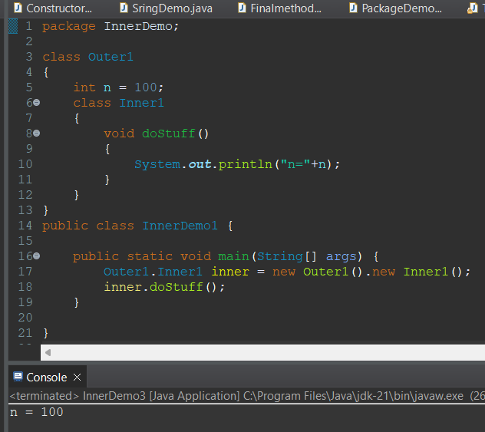

- Method local inner class : Inner class is created within a method of outer class

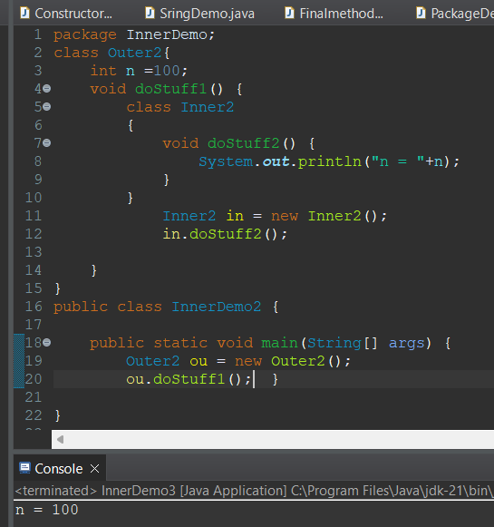

- static inner class : The object of static inner class is created without using the object of outer class

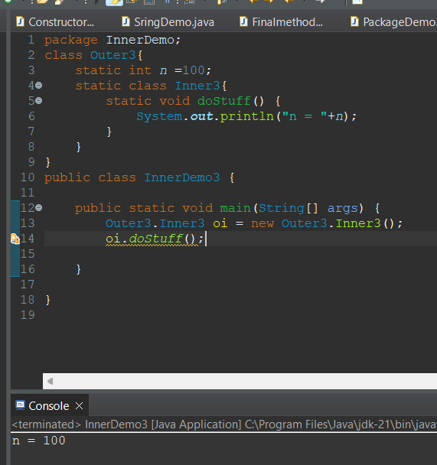

- Anonymous inner class

Classes

-------

- Object

- String

- StringBuffer

- StringBuilder

- System